**Two- and Three- Gamma Positron Annihilation Imaging Using a Gamma-Ray Tracking Detector**

# Abstract

The GRETINA detector assembly, a high purity germanium gamma-ray tracking array, is a state-of-the-art device for performing coincident gamma-ray measurements in nuclear structure experiments. In some of its configurations, the array can also be used as a nuclear imaging device with gamma ray energy resolution on the order of 2 keV at 511 keV. During a GRETINA campaign at Michigan State University, the characteristics of nuclear imaging with GRETINA were investigated by tracking photons from both two- and three- photon positronium-annihilation events originating from sodium-22 sources and a fluorine-18 phantoms. Two-gamma tomographs were generated in two-dimensions using a filtered back-projection reconstruction algorithm. A ~6 mm diameter sodium-22 source reconstructed at different locations within the detector. These images were compared to simulations used to benchmark the reconstructions, measure the resolution, and to interpret the factors impacting the image resolution. Measurements on the image resolution resulted in a FWHM in the x direction of 5.8mm and a FWHM in the y direction of 5.3mm. For the three-gamma imaging, decays from a different thin film sodium-22 source with a ~5 mm diameter were reconstructed with widths of 16.2 mm in the *x*, 13.1 mm in the *y*, and 10.5 mm in the *z* dimensions. Monte Carlo simulations were employed here and produced best case scenarios on the potential point resolution of three-gamma imaging.

# Introduction

Positron-emission tomography (PET) is a valuable technique in nuclear medicine. In clinical practice it is used primarily for detecting and observing metabolic processes linked to cancer. More generally, PET provides physicians a tool to noninvasively determine the chemical and biochemical nature of lesions without resorting to biopsy. There are many areas of active research to improve PET such as in designing more-specific radiopharmaceuticals, advancing reconstruction algorithms, and developing additional radioisotopes for use in tracers [1]–[3]. Further, new detector technologies are constantly being integrated into PET scanners in order to improve image resolution and quantitation by reducing response time, increasing sensitivity, and increasing interaction-point precision.

Traditional PET imaging requires a ring of detectors in order to intercept and detect two 511 keV photons resulting from positron annihilation [4]. The individual detectors are typically made up of a scintillator material connected to a photomultiplier tube. For the scintillator material, many different materials are available and commonly used. This includes NaI:Ti or Lu2SiO5:Ce in the activated scintillator category and bismuth Germanate (BGO) as a self-activated scintillator [4]. The most important factors for these PET detectors are that they can identify 511 keV annihilation photons efficiently, have fast timing response, are low cost, and have moderate energy resolution [4].

High purity germanium (HPGe) detectors are rarely, if ever, used in PET scanners because of the high infrastructure cost involved but provide superior energy resolution when compared to scintillator based detection. This energy resolution can allow for more precise energy discrimination, which can limit the influence of forward scattered gamma rays on PET resolution amongst other advantages. Recent advances in HPGe detectors, primarily used in the field of nuclear structure, employ advanced gamma ray tracking techniques. These gamma-ray tracking arrays such as the GRETINA [5] array or the AGATA [6] system, are now capable of resolving detector-photon interaction points to within a few millimeters. This spatial and energy resolution makes them attractive for imaging techniques such as two and three gamma PET as well as the possibility of multi-source imaging; third-gamma PET tagging; and Compton camera imaging.

Three-gamma PET imaging has been described by Kacperski and Spyrou [7], [8]. It is based upon the observation that the precursor to positron annihilation, positronium, can exist in either an ortho- or para- state. Para-positronium decays rapidly, primarily by two-photon annihilation, whereas ortho-positronium has a longer lifetime and decays either by transitioning to the para- state through interactions with the external environment or by three-photon annihilation. In the three-photon annihilation case, if all three of the photons’ energies and interaction loci can be determined, then a single event can be reconstructed to a point (rather than a line, or “line of response”, that is used for traditional two-photon PET imaging). The GRETINA array is a promising device for three-photon imaging because it can provide both the energy and interaction locus for detected photons with very high precision.

For the current work we used the GRETINA detector array to measure photon energies and photon-detector interaction points following positron annihilation from sodium-22 and fluorine-18 sources. These data sets were used to reconstruct two and three photon-based tomographs in order to determine the resolution of PET imaging using a gamma ray tracking detector. The results point to interesting future imaging work that will become possible by adding gamma ray tracking detectors to the suite of imaging techniques available for basic and applied science research.

# Two-gamma PET imaging

## Methods

For the tagging of two 511keV annihilation events in GRETINA a gating procedure using the energies measured in the individual germanium crystals was used. In a first step, all detector energies in an event were added in a calorimeter spectrum, while an event is determined as all detector hits within a time interval of about 100 ns. Only those events were taken into account for further processing which added up to 1022 keV in the calorimeter spectrum. In a next step the add-back procedure as outlined in [9] was employed, which essentially adds the energies of two neighboring crystals together, i.e. treats those events as a scatter from one detector into its neighbor. From the resulting data those events were selected were a pair of energies of 511 keV each could be found. Usually more than one interaction point is reported for detector events of 511 keV energy. For image processing only the coordinates of the first interaction point of a 511 keV hit is of importance and always the interaction point with the highest energy deposition was chosen as such. While this is a very simplistic approach, Weisshaar et al [9] showed that it delivers a better result for extracting the first interaction point compared to employing a gamma-ray energy tracking algorithm.

For 2-D reconstructions, the data initially were compressed in the *z*-axis by setting the *z* value of each detection to zero. In both configurations, GRETINA was assumed to be a planar array. The focus was on the center between the detectors, and the detectors were relatively far from the focus (*Ø* = 40 cm) compared to the size of the object being imaged (22Na source *Ø* = 10 mm, and 18F phantom *Ø* = 8 cm*)* making a planar array a reasonable approximation.

After flattening the data into a 2-D plane, the event Lines-of-Response were binned by their polar angle to create a sinogram. The sinogram was then converted to a tomograph using Scikit-Image’s “iradon” function [10]. This function reconstructs a tomograph using filtered back projection with a simple ramp filter. It is worth noting that iterative reconstruction methods were also tested, in particular, the Simultaneous Algebraic Reconstruction Technique or SART. SART did not lead to more useful pictures and were complicated by the fact that the GRETINA array did not form a complete ring.

Source simulations were created and compared to the real data reconstructions. The same simulation was then later used in a point source to measure the detector’s PET resolution. To create the simulation, an autoradiograph was used to characterize the source that was used. This data was used as a weighted probability for the initial position of a decay. After getting the decay position, Monte Carlo methods were used to simulate photon detections. After the first photon’s initial direction was randomized, it was checked against the angular distribution of GRETINA. If the first photon was accepted, the second photon’s angle was calculated and compared in the same way.

## Source 1 Measurements

Source 1 was a sealed 0.01 µCi Na-22 source ~6 mm in diameter with an abnormal source distribution. This source was placed inside of the field of view of the GRETINA array, and moved around to six different positions sequentially over the course of several hours. During data collection, the interaction loci of coincident 511 keV photons were recorded for reconstructions. For the sake of description, the source positions were nominally 3 o’clock, 6 o’clock, 9 o’clock, 12 o’clock, and center relative to the lab frame and approximate center of the GRETINA array.

For the Source 1 campaign, GRETINA was arranged under the configuration found in figure 1, herein referred to as configuration 1. Figure 1(bottom) gives the angular distribution from a GEANT4 simulation of a single photon point source in configuration 1 where theta is the polar angle and phi is the azimuthal angle. With 28 active hexagonal sections, the first configuration lay solely in the θ=π/2 plane. This configuration had the most detector pairs for measuring the two gamma 511 keV peaks 180° from each other. The angular distribution plot lines up with figure 1(top) through the axis overlaid the center of the detector while the reconstructions found later are relative to physically standing in the lab looking down the beam line.

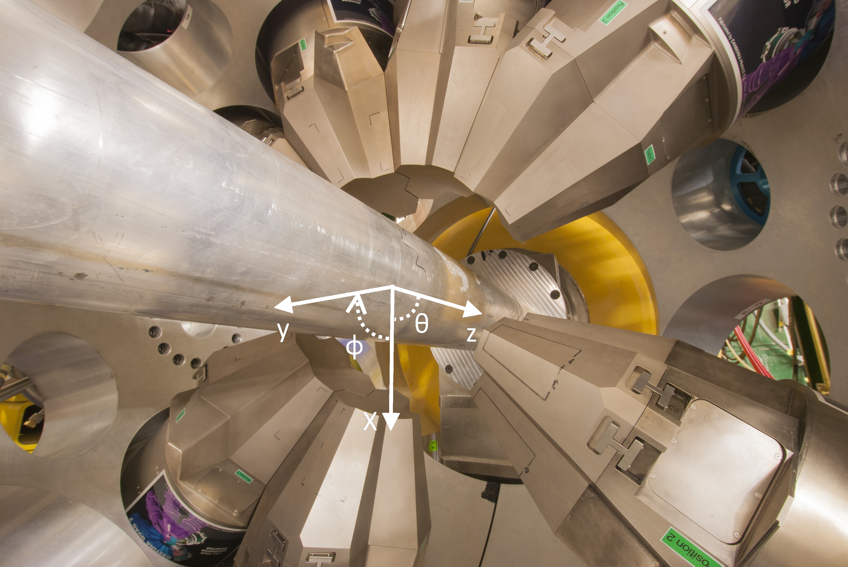

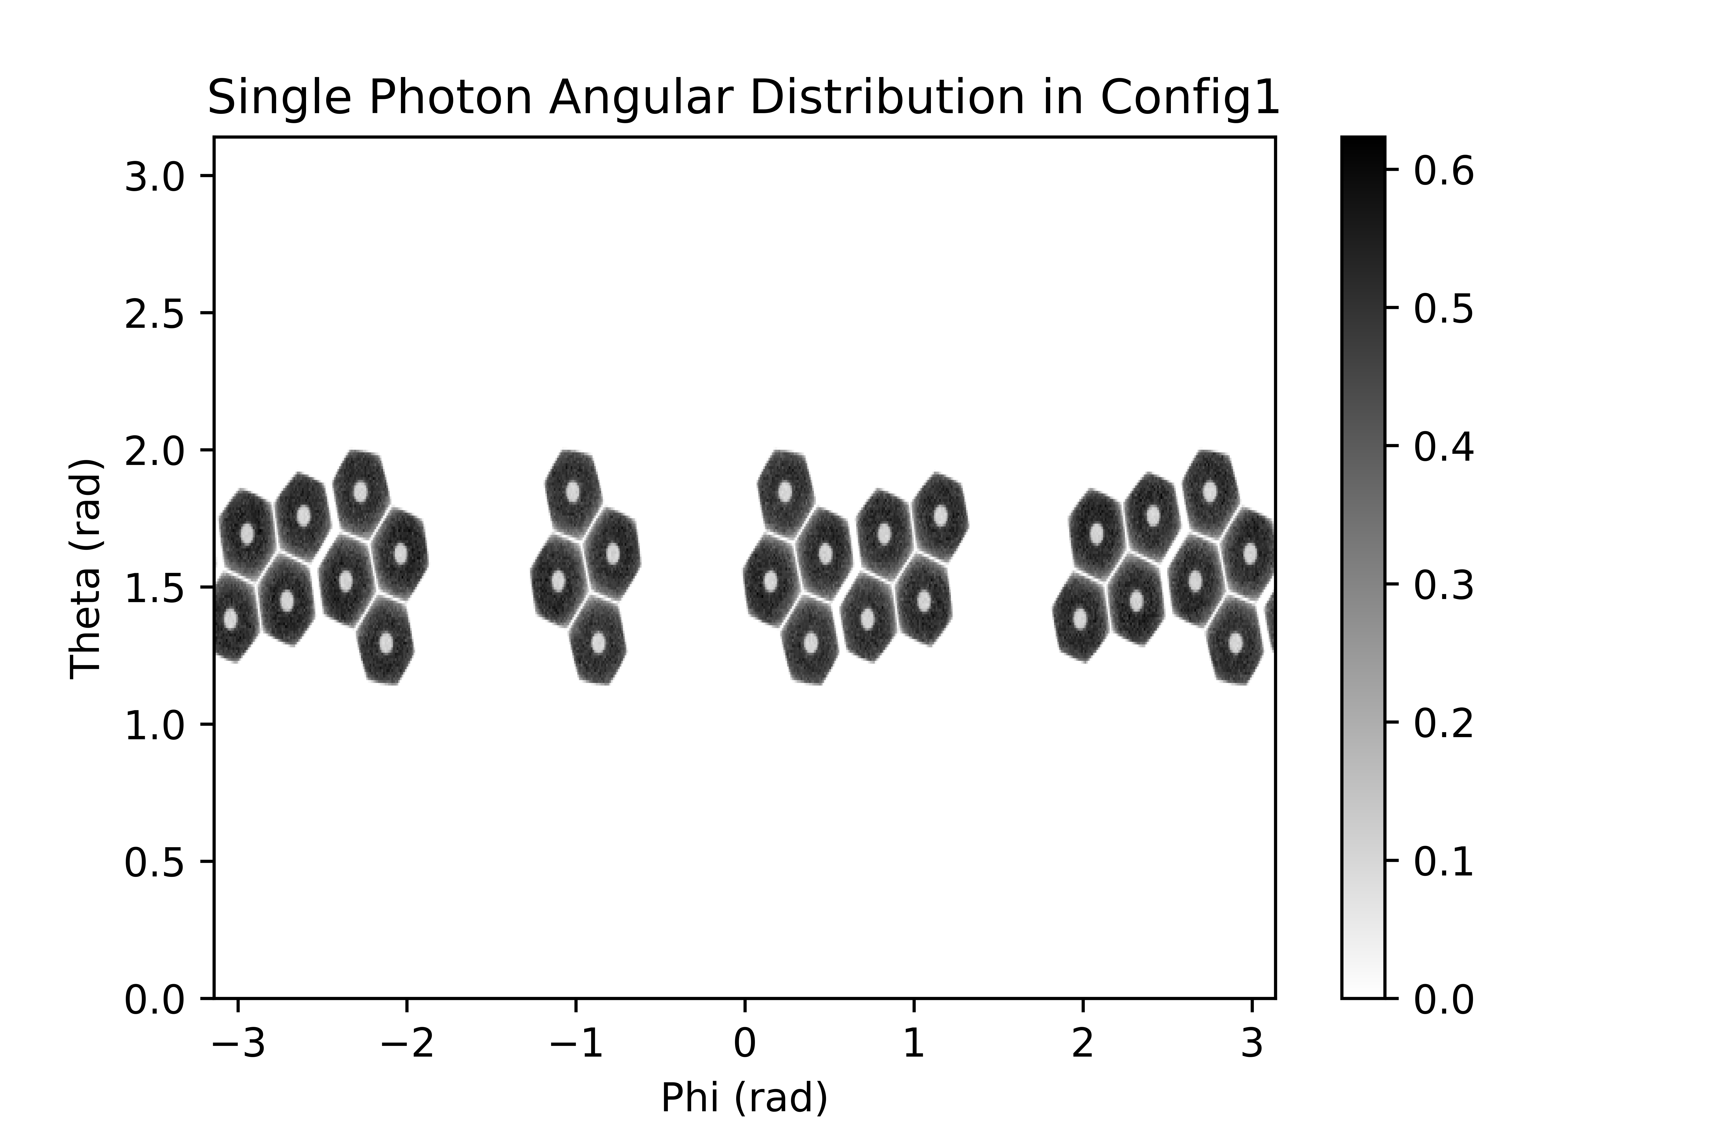

Figure 1. (top) Picture of GRETINA in configuration 1 along with the internal detector coordinates. (bottom) Angular distribution of a Geant4 simulated point source in GRETINA for source 1 where there were 28 active hexagonal sections.

For Source 1, data were reconstructed as one data set with an equal number of events from each position. The tomograph for source 1 is shown in Figure 2(left). In the reconstruction, 5 distinct points are visible with the clock labels corresponding as if a clock was centered between all the points. The effects of the unoptimized detector geometry is qualitatively visible in the reconstruction. For figure 2, the detector geometry in the first configuration causes a back-projection with an “x” pattern. This originates from gaps 180° from each other where the detectors aren’t paired. Because of this the reconstructions are skewed towards the detector positions.



Figure 2. (left) 2-D reconstruction of source 1 taken by flattening the z-axis points with each pixel 1x1mm and a 20x20mm grid overlaid. (right) Reconstruction of simulated data for the source 1 where detector position resolution was set to σ = 3mm. These images are set side-by-side to make comparison between the two easy.

Figure 2(right) is the reconstruction for the simulated source 1 data using the simulation described in the methods. The detector position resolution was measured using a 1D grid search over uncertainties. Each was simulated and compared by a mean squared error value against the real Na source reconstruction. This resulted in a detector position resolution of σ=3 mm as the least error between the two. This is at the high end compared to the reported detection position resolution of σ=1.9 ± 0.9 mm [5]. This detector uncertainty determined was important for the PET resolution measurement described later.

In comparing the real and simulated reconstructions, there is a large visual difference between the 6 o’clock points. While the simulated 6 o’clock has some of the stretching seen in the real data reconstruction, it is incomplete in the severity of how much it is stretched. This hints that there is a strong position dependence on the reconstructed point due to the detector geometry. In figure 3, the sodium source is simulated moving down in the y-direction and then back over in the x-direction. The point at (0, -60) is only ~20 mm lower than the actual 6 o’clock point at (-1, -38) but reconstructs with a much lower resolution because it moves out of view of a detector pair. This strong dependence on position around the 6 o’clock point can account for the difference in the simulation compared to real data.



Figure 3. Reconstructions of single point simulations at different positions in order to compare the position dependence. The coordinates correspond to figure 2 when the origin is set at x=y=60. For reference, in the real data, the 6 o’clock point is located around (-1, -38).

For the PET resolution measurement, a point source was simulated using the same simulation as well as the determined detector position resolution of σ=3 mm. This was to take out the uncertainty of the abnormal source geometry and provide the reconstruction resolution dependent only on the detector geometry and position detection uncertainty. A one dimensional Gaussian distribution was fit to the point source reconstruction in order to quantify the resolution. For the point source reconstruction, the resolution was measured as FWHM-x = 5.8 mm (σx = 2.5 mm) and FWHM-y = 5.3 mm (σy = 2.3 mm).

## MicroPET Phantom Measurements

The microPET phantom was provided by the Department of Medical Physics at the University of Wisconsin – Madison [11]. It was fabricated in two parts using 3-D printing with laser cut gaskets and glass-filled nylon nuts and bolts. A small amount of radioactivity was present from previous experiments, and remained throughout the experiment (0.29 ± 0.02 µCi 54Mn and 0.67 ± 0.01 µCi 57Co). The phantom was filled with 12.9 µCi of [18F]NaF in water.

For the phantom experiment, GRETINA was operated under the second configuration found in figure 4. There are more active sections (40) than in the first configuration (28), but there are less detector pairs arranged appropriately for two-gamma imaging. The whole detector setup was also less planar, with a θ≈π/3 plane in addition to the θ=π/2 plane. Because of this, the phantom was centered in GRETINA’s x-y plane but kept slightly forward in the z plane in hopes of keeping more detector pairings needed for registering two-gamma coincidences.

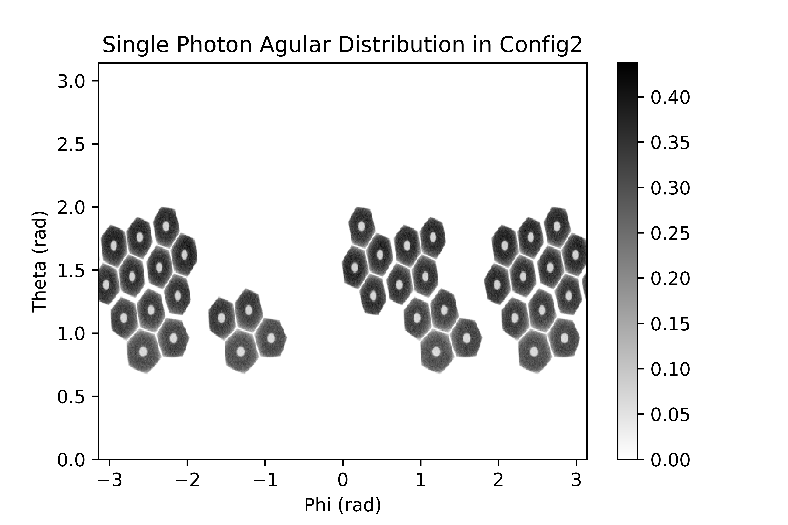

Figure 4. Angular distribution of a Geant4 simulated point source in Gretina with 40 active hexagonal sections. This configuration is used for the micro-PET phantom and source 2 data collection.

The reconstruction as well as an overlay of the phantom’s rod diameters can be seen in Figure 5. An overlay of the phantom tubes with the diameter measurements are seen in figure 5(right). The reconstruction resulted in a similar cross pattern as the reconstruction from the first configuration except the (*-x,+y*) to (*+x,-y*) lines result from the out of plane detectors.

While the points were able to be resolved before in the Source 1 reconstructions, the phantom columns were not resolved. In this case the activity distribution was much more compact than in the Source 1 experiment, and spacing between the rods was lower than what could be resolved. However, the sections between the triangle-shaped wedges were clearly visualized. These sections show up in the reconstruction as the lighter sections creating a cross pattern in the center of the image. There is one missing line that would complete the cross pattern that would run horizontally through the image, but it lines up perfectly along the “+” shape where there were no detector pair. Without the back projection along that direction, the reconstruction could not highlight the aisle that would split the last set of wedges.

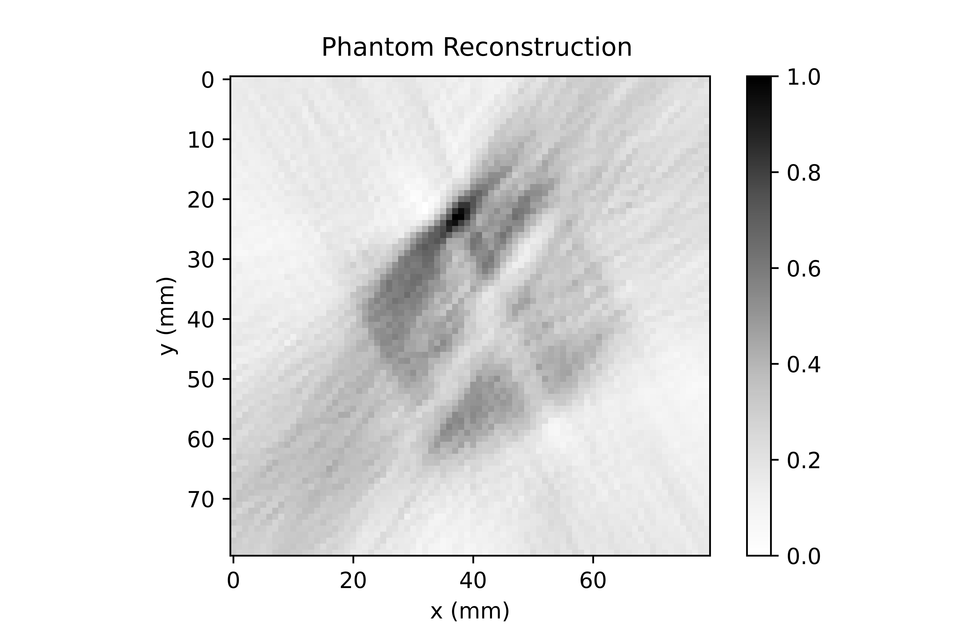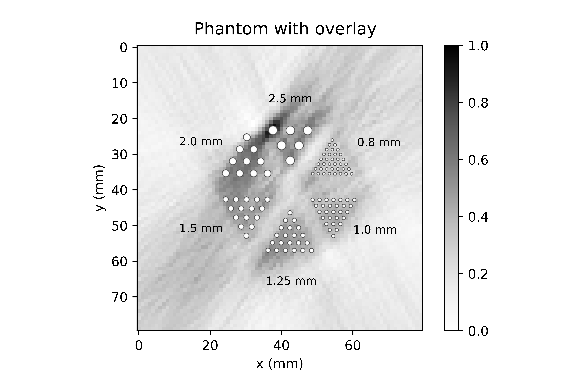

Figure 5. (left) Phantom reconstruction in 2-D by flattening the z-axis from real data. (right) The same phantom reconstruction with overlaid tube sizes. The overlaid phantom shows the diameter of the tubes while the center to center distance is twice the tube diameter. The aisle between the wedges differs but is approximately 7mm.

Simulations of the phantom accounting for detector geometry and detector position resolution were used to confirm that the phantom reconstruction in figure 5 was accurate. The simulations preformed for the phantom were similar to the simulations used earlier to model source 1. In this case, the dimensions of the phantom are well known and it was assumed the F-18 was even distributed within these dimensions. For this simulation, the second configuration, seen in figure 4, was the probability density function used in the simulation. The simulation also kept the earlier measured detection position uncertainty with a σ = 3 mm. The reconstruction of this simulation can be seen in figure 6 along with an overlay to show the size of the rods. Compared to figure 5, the simulated data results in the same loss of resolution within each wedge and the loss of the horizontal cross pattern can be seen.



Figure 6. (left) Reconstruction of the simulated F-18 phantom source with GRETINA in configuration 2. The detection position resolution was set to σ = 3mm. (right) The same reconstruction with an overlaid phantom showing the size of the holes.

## Conclusion for Two-gamma

From two-gamma PET imaging with Source 1, simulations were used to measure the image resolution as FWHMx = 5.8 mm (σx = 2.5 mm) and FWHMy = 5.3 mm (σy = 2.3 mm). Simulations also showed that this image resolution was highly position dependent within the configuration as having equal weighting on the detector pairings was crucial. Source 1 was spatially separated from each other and had more detector pairings allowing for a clean determination on GRETINA’s image resolution.

The combination of stretching from the unoptimized detector geometry as well as the detection position uncertainty mostly accounts for the loss in image resolution. The fitted detector position uncertainty at σ = 3 mm measures slightly higher than the reported GRETINA’s position uncertainty at σ = 1.9 ± 0.9 mm [5]. While this uncertainty is partially inherent to the detector, it might be slightly improved with algorithm work, especially on the low end of the energy spectrum where we find this experiment.

The phantom reconstruction was ambitious and ultimately left qualitatively unresolved. This was attributed to GRETINA’s current detection position uncertainty as well as limitations in detector geometry. With a full ring of detectors, the weighting of the image would also be approximately equal in every direction. This would remove stretching of image in the “x” shape resulting in a cleaner picture and resulting in resolving the third cross through the phantom. This in combination with an improvement in detection position resolution could be the push that gives enough clarity for a phantom image at this scale. This could also open the doors for iterative reconstruction algorithms to reconstruct the image rather than filtered back projection.

# Three-gamma PET imaging

## Methods

Tagging three-photon decays from the 22Na source data was achieved by only considering events in which exactly four detector crystals did fire, one crystal registered a 1275 keV gamma-ray energy, and the energies of the remaining three crystals added up to 1022 keV. In addition, none of those three detector energies was allowed to be larger than 500 keV, reducing the chance for falsely selecting a true-two photon event scattering between three crystals. Exploiting the lifetime of ortho-positronium, calculated as 142 ns [12], a timing condition was set that all three detectors were delayed at least by 40 ns and up to 250 ns with respect to the detector which detected the prompt 1275 keV energy from the daughter 22Ne. It has to be noted that the timing properties of the GRETINA detectors at those lower energies exhibit a slow response component which can be mistaken as a delayed gamma ray [9]. The remaining events were further filtered by demanding that each of the three detector pairs forms an angle between 20o and 160o with respect to the center of the detector array where the source was placed.

### Three Gamma Triangulation

Unlike the two-gamma case, the three-gamma decay can be reconstructed back to a single point of decay. Gajos et. all proposed to solve for the point of annihilation with trilateration based upon knowing the detected photon’s position and time [13]. Here, instead of relying on the fast timing of the jPET detector, GETINA’s energy resolution is utilized. From the energy, the angles between the outgoing photons can be uniquely determined. By coupling this kinematic information with the points of detection, the point of annihilation can be found by triangulation.

The first step in triangulation reconstruction is to determine the angles between each photon by utilizing conservation of momentum for the total annihilation interaction. This gives the angles between the momentum vectors as functions of the energies of each photon. When linearly transformed, these vectors point in the direction of their detection points, as seen in Figure 7.

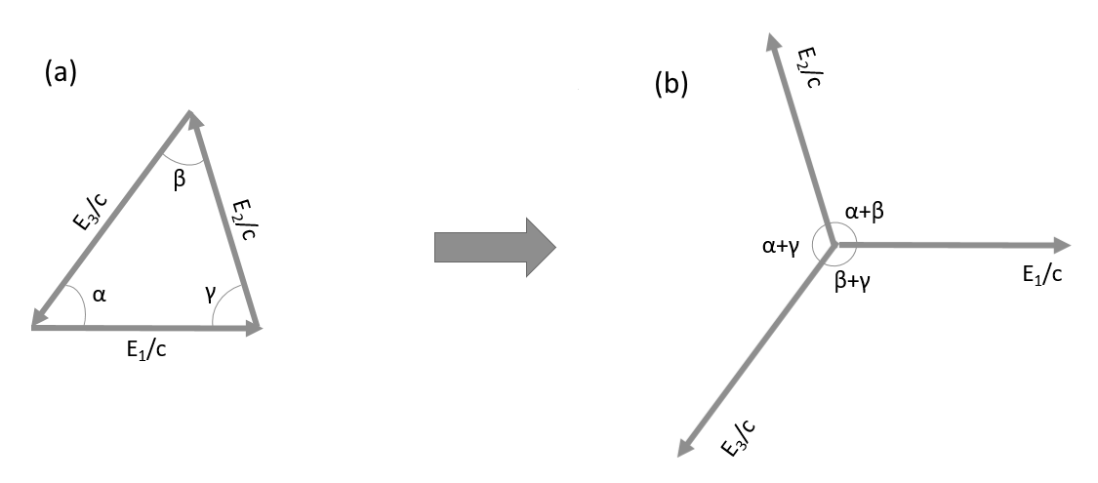

Figure 7. a) Conservation of Momentum vectors cancel leaving angles between. b) vectors point to detection points

An arc of the possible decay positions can be swept out inside the detector using one of the combinations of α, β, and γ as an inscribed angle as well as the two detections the angle points to. Three arcs can be extrapolated within the circle of detectors using each angle in combination with the related points of detection. These three arcs all intersect at one point, the point of decay, as seen in Figure 8. An in depth explanation of the method used for this study can be found in the appendix under the three gamma triangulation algorithm.

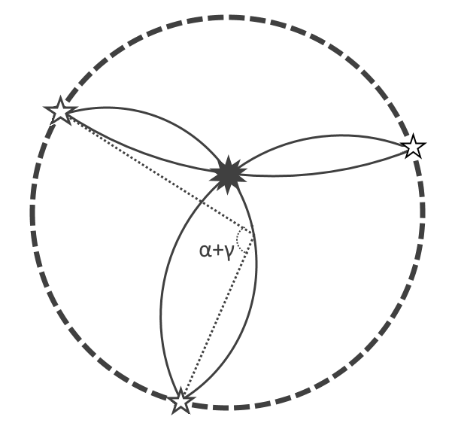

Figure 8. Diagram of reconstruction with the 3 arcs intersecting at the point of decay. One of the inscribed angles are labeled with the five pointed stars being the location for where the gamma was detected.

## Source 1 Measurements

Source 1 here refers to the same source 1 mentioned above in the two-gamma imaging. Source 1 had 6 different spatial locations of the 0.01 µCi source and was run under GRETINA configuration 1.

The data obtained from Source 1 were also analyzed for three-photon annihilation events. With detector pairs forming an angle between 20°-160°, described above in the methods/data reduction section, only 91 suspected true three gamma events were retained, which reconstructed to the image seen in Figure 9(left). The reconstruction struggles with the lack of data but some activity in the center can be observed with less confidence that there is activity around it at the 3, 9, and 12 o’clock positions. Events from the 6 o’clock position are missing.

Without the angle cuts, 572 points of data were extracted with the reconstruction of this data set seen in Figure 9(right). False reconstructions start building up in the location of the detectors without gaining much additional resolution in the center. These are suspected to be due to Compton scattering within the detector that originated from a 2 gamma decay where one photon deposited the correct energy in two different segments that were next to each other. This same pattern was observed later in the source 2 data set as well.



Figure 9. 2-D histogram of three gamma reconstructions on the source 1, 0.01 µCi Na-22 data set. (left) reduced data based on the angle cuts made to the data. (right) All possible three gamma events with reconstructions within the area of the detector. Bins in both are set to 7.5x7.5 mm.

## Source 2 Measurements

The lack of data from Source 1 motivated the Source 2 experiments, with a higher source activity, and a longer data collection period. Source 2 was a thin 1 µCi Na-22 source with a ~5 mm diameter, with a thin film window that allowed positrons to enter an alkaline oxide powder, with the aim of improving ortho-positronium retention. This source was measured for a longer period in a single location in the center of the GRETINA field of view. For this measurement, GRETINA was arranged in the “second configuration” shown in figure 4.

For this data set, 2001 suspected true three-gamma events were collected and reconstructed. The reconstruction can be seen in Figure 10. Each of the three-gamma events detected was reconstructed to a single point but a projection was taken to view the density of points. The ~5mm diameter, thin film- source, centered slightly off center, provided data that reconstructed with fwhms of 16.2 mm in the *x*, 13.1 mm in the *y*, and 10.5 mm in the *z* dimensions. Discussion on how this plays into the resolution for a points source is discussed in the simulation section.



Figure 10. Projection of the 2001 point reconstructions of source 2 three-gamma events onto the XY plane. Bins are 1x1mm with a 5x5 mm grid.

## Control Cases

As the extracted yield of three-photon decay events was very small and to ensure that the results from the imaging processing is not just an artifact from the selection procedure, two control data sets were constructed. In a data set measured with 60Co, events were selected with three detectors adding up to 1022 keV and none of the detectors exceeding 500 keV, similar to the energy conditions used for the three-photon selection in 22Na. Of course, in the case of 60Co those events must be Compton-scattered 1.17 MeV and 1.33 MeV gamma-rays not completely absorbed in the GRETINA array. Similarly, events were selected from the 22Na measurement in source 2. Here, the same gating as for the 60Co source was used but the energy gate on the calorimeter spectrum was actually moved a little higher to 1030 keV. This ensured that those events cannot be formed by just the annihilation gamma-rays of a positron but must have contributions from the 1275 keV gamma ray.

The cobalt source lacked a β+ decay to create positronium for the three gamma events but it did have two high energy gamma rays that are similar to the 1275 keV gamma originating from sodium-22 decay. Figure 11(left) is the result of the three-gamma reconstruction algorithm on this data. This reconstruction had similar events to “All Source 1 – Three-Gamma Events” (seen in figure 9(right)) where Compton scattering events reconstructed primarily inside of the detector.

The sodium-22 (Source 2) dataset with incorrect energy values reconstructed in a more uniform distribution (seen in figure 11(right)). They were close to the correct energy being only ~10 keV away from the 1022 keV needed for a true three gamma event. Out of 4801 detector coincidences, 3323 were able to be reconstructed with many of these failing because they reconstruct outside of the detector’s radius. Out of those, 63 points reconstruct within a 20 mm radius from the center. As this data was cut just above the limit that three-gamma decays are found, it is not unreasonable to expect a few real events are represented with the reconstructions in the center. Taken independently, those 63 central reconstructing points displayed detection patterns in energy and position similar to the expected true three gamma events taken from source 2.

It is important that a majority of the data did not reconstruct well. The events in this data set had little to no possibility of being just a two-gamma event that scattered within the detector to imitate a three-gamma event. One of the photons would have been incompletely captured recording an energy less than 511 keV while the other would need to scatter once and be detected in two spots with a total energy much higher than 511 keV. There is still a 1275 keV gamma that could interact with a scattered 511 keV gamma or even a capture of two out of three gammas from a real three gamma event. There could be two incompletely absorbed 511 keV events

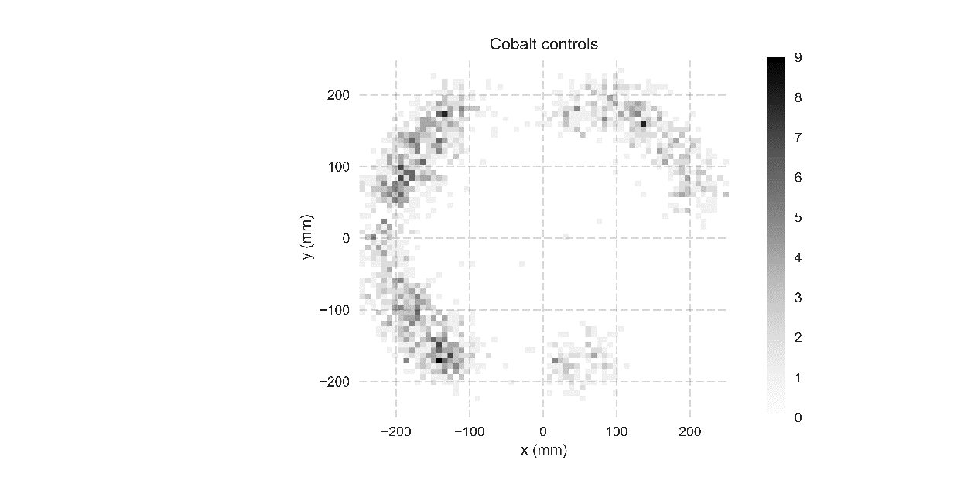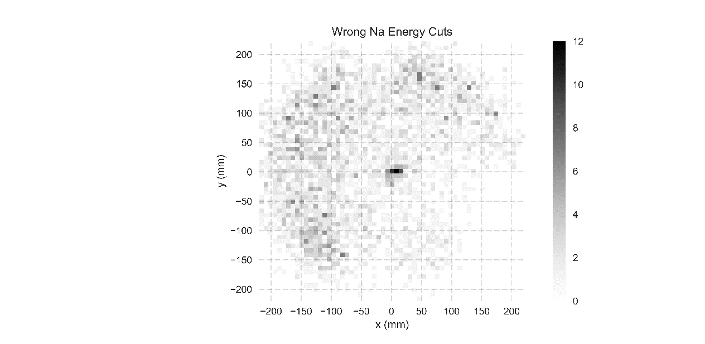

Figure 11. (left) Cobalt-60, a β- emitting source with the same data reduction used for all three gamma data. (right) Sodium-22 source with energy peaks centered around 1030 keV with the same data reduction used for all three gamma data. Bins in both are set to 7.5x7.5 mm.

## Simulation of Three-gamma

The effects of the inherent energy and position resolution of GRETINA were studied using the simulation of a three gamma decay. These simulations are a small change from earlier used two-gamma simulations. Monte Carlo simulations were again employed starting with a set of ideal three-gamma events. The simulation started with autoradiograph data. This allowed for an accurate sampling of activity in the source giving appropriate points of annihilation. The energies were then randomized and split similarly to Kaminska’s method[14] with energies based on the Ore-Powell distribution [15]. Finally, an initial decay direction was selected determining the other two detection locations as well. All three of these detections were then compared against the probability density function of GRETINA in configuration 2 (figure 4). Cuts to the data based on the angular distribution and energy spectrum were performed to match as described in the methods.

The simulated events had perfect detection position and energy resolution allowing for the manipulation of this after the fact. Each point was given a normalized position error with σ = 3 mm to match the position detection error and an energy detection error of σ = 0.85 keV (~2 keV fwhm typical for HPGe). The results of the simulation can be seen in figure 12(right) in comparison to the source 2 experimental data reconstruction in figure 12(left) (same as figure 10). These images are undoubtedly very different from each other. This difference continues with higher position detection uncertainties as well. The radial distribution of the reconstructed points never matches the experimental data.

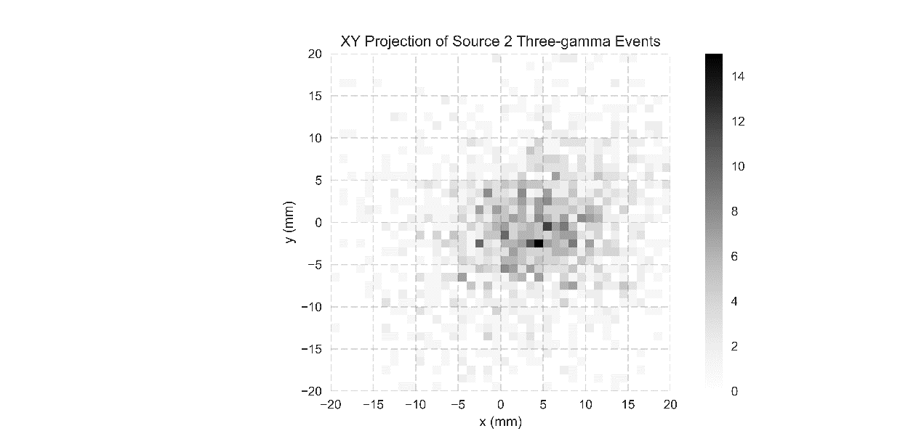



Figure 12. (left) reconstructions of source 2 three-gamma events onto the XY plane. (right) simulation of source 2 with position detection uncertainty set to σ = 3 mm and energy detection uncertainty set to σ= 0.85 keV. These images don’t match well indicating the simulation can only be the best case scenario.

While the simulations didn’t match the experimental data, they give a best case scenario which was useful in exploring the interesting properties of three-gamma imaging. The resolution for a point source was measured using the same detection uncertainties of σ = 3 mm and σ = 0.85 keV and the resulting image was fitted with Gaussian functions. This resulted in a FWHMx = 7.1 mm (σ = 3 mm) and a FWHMy = 5.9 mm (σ = 2.5 mm). The point source measurement was then taken further to view the effects energy detection uncertainty and position detection uncertainty had on the final three-gamma image reconstruction. The results of adding on this error in the simulation can be seen in figure 13. Here each plot is reconstructed assuming zero error in the other type of detection error, so finding the resulting error requires adding the uncertainties due to position detection and energy detection in quadrature.

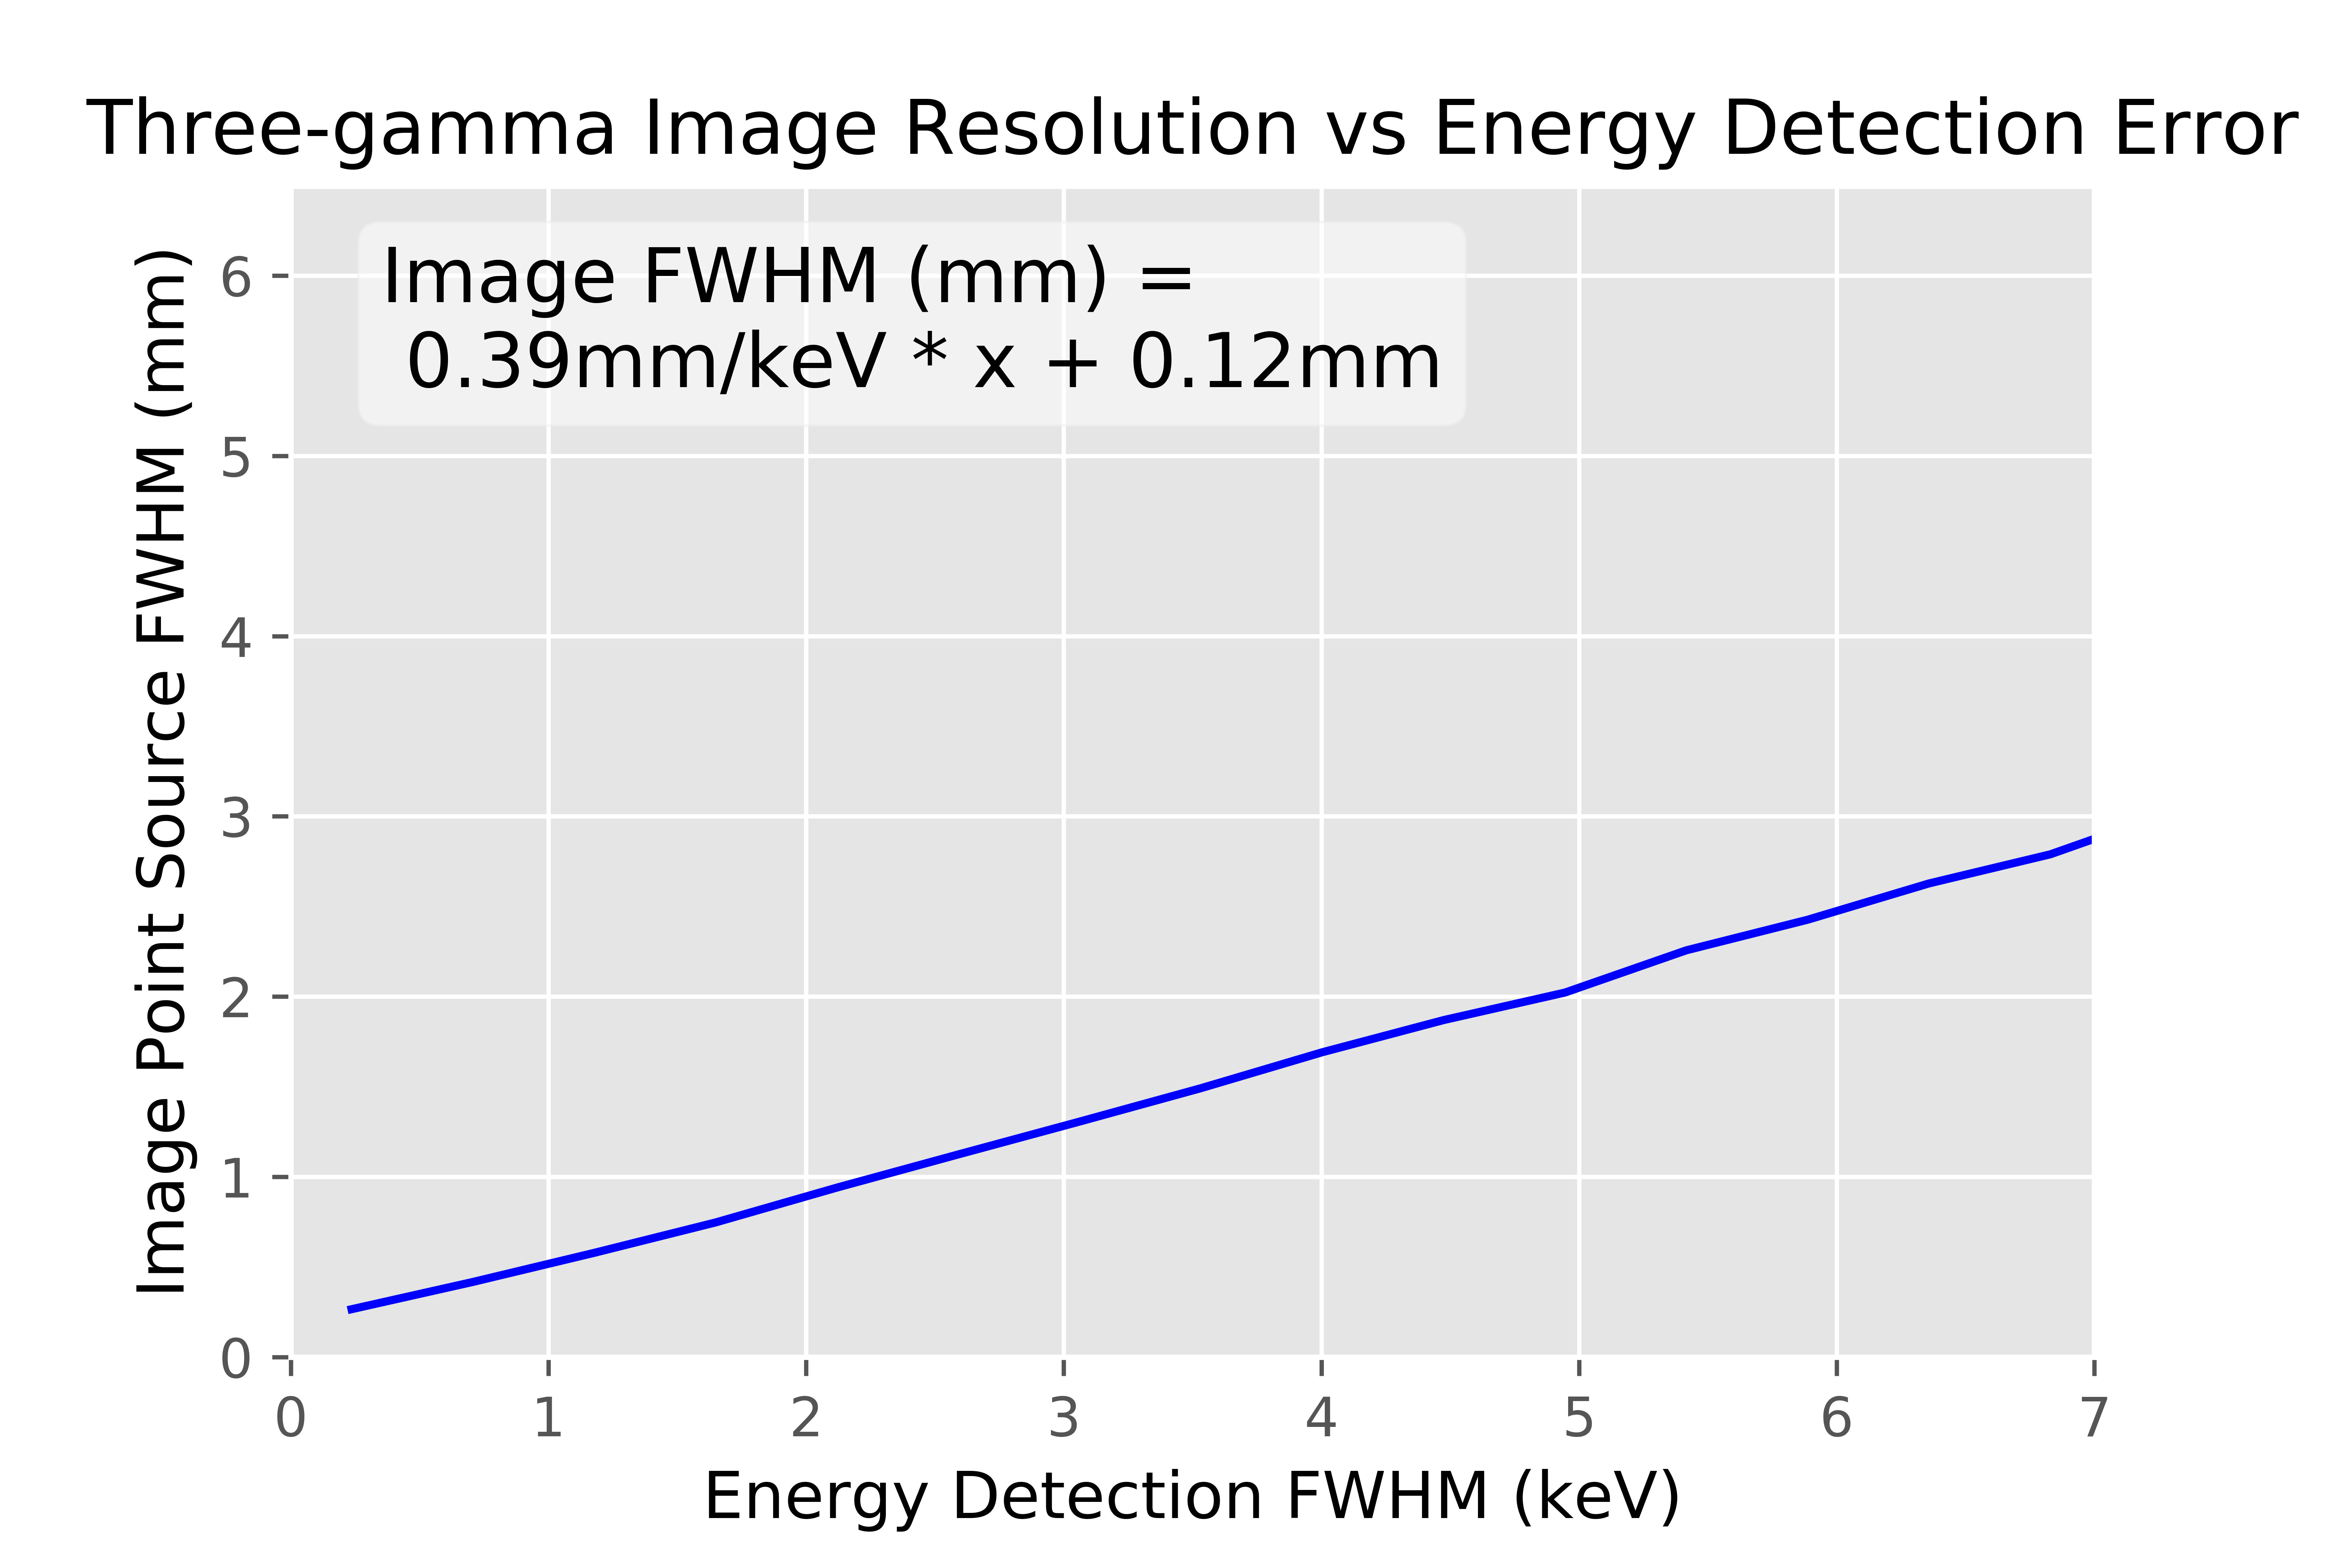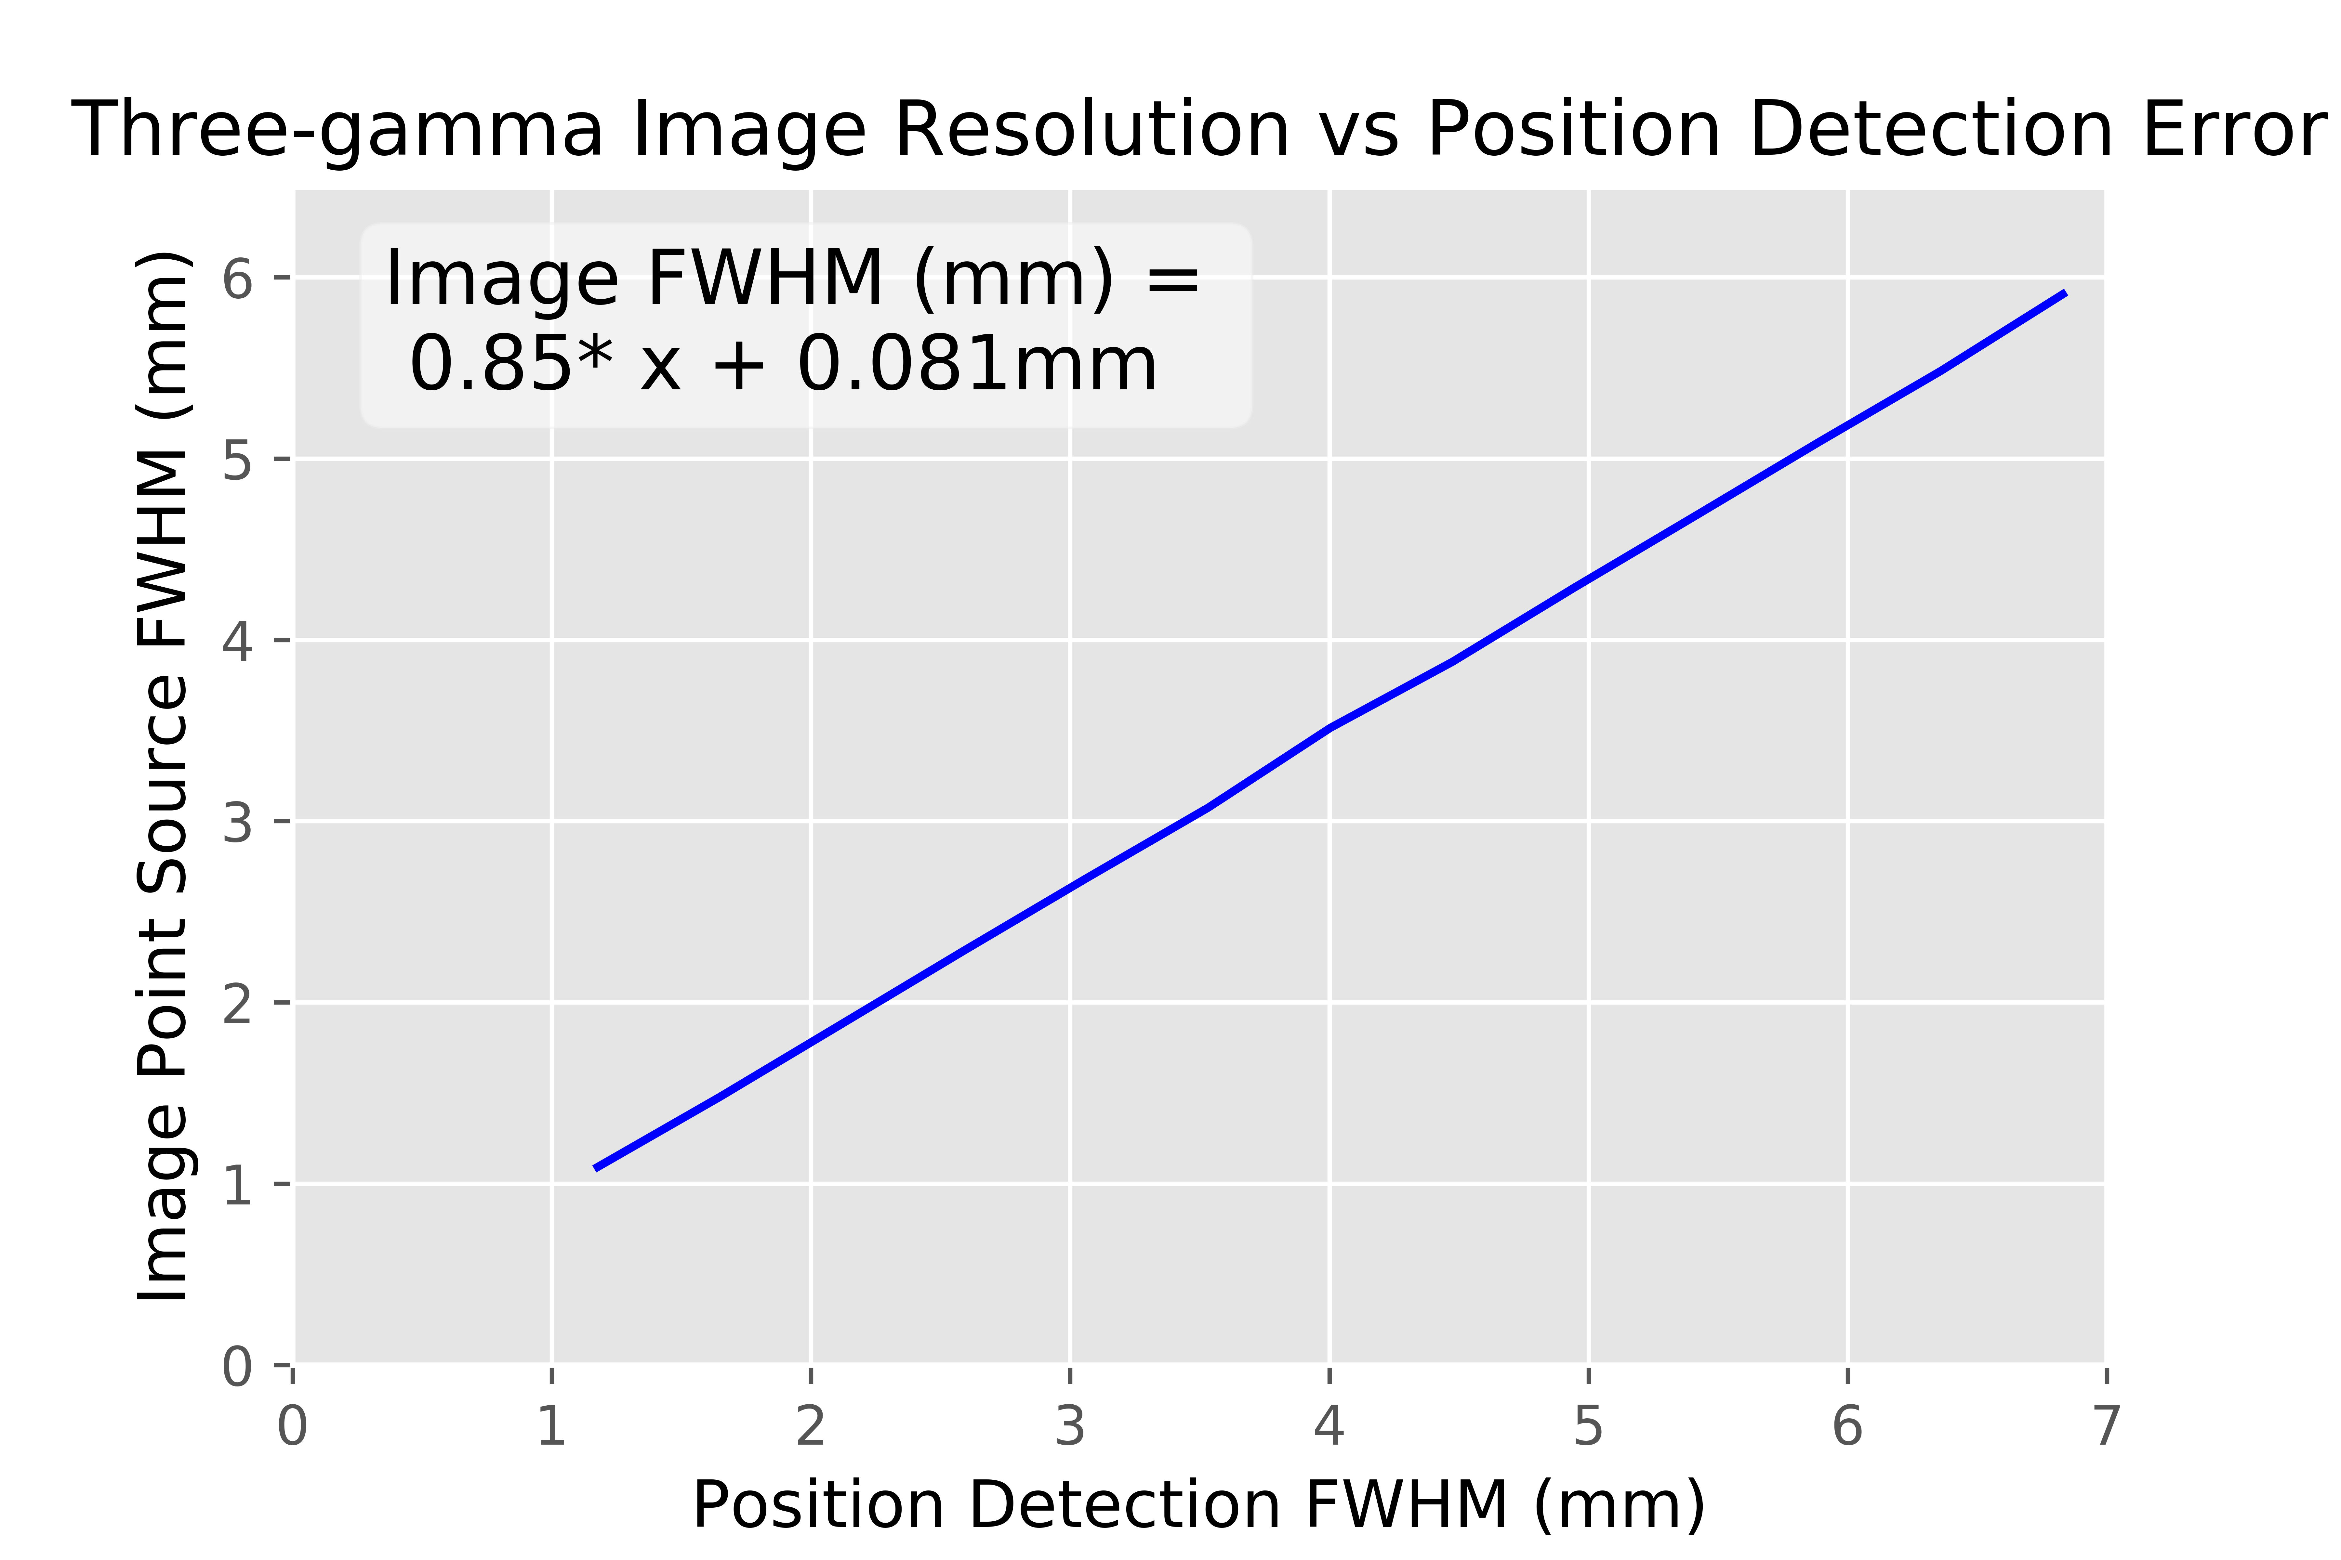

Figure 13. (left) Simulation results showing the relationship between the energy detection error and the three-gamma image’s resulting resolution, keeping the position detection error at zero. (right) Simulation results showing the relationship between the position detection uncertainty and the three-gamma image’s resolution. The energy detection error was kept at zero.

The resolution as a function of position within the field of view of the detector was also analyzed in terms of the energy distribution. A grid search was done giving a 2 keV energy detection error. It was found that reconstruction error was minimized as the annihilation energy was evenly distributed between the three photons (*e1=e2=e3=1022/3* keV). The error only spikes up drastically when one energy is small enough that a change in 2 keV is a large fractional error. Due to the way the data was gated, events like this were not present in the experimental three gamma data. GRETINA’s configuration mostly determines detection efficiencies which can weigh the reconstruction in different directions.

## Conclusion for Three-gamma

For the three gamma imaging data, source 1 gave the first insight on being able to tell sources apart from each other. Source 1 also highlights the need for more counts in the data as one of the points is non-existent and the others are faint. Source 2 showed what is possible with more three-gamma events. The ~5 mm diameter thin-film source (Source 2) reconstructed with widths of 16.2 mm in the *x*, 13.1 mm in the *y*, and 10.5 mm in the *z* dimensions. Control data sets confirmed that the grouping and reconstructions seen in the source 1 and source 2 are non-accidental, that they don’t reconstruct favoring a central reconstruction. Finally, simulations gave estimates for a best case scenario on the three gamma resolution and the relationship between the detector’s uncertainty and the resolution of the reconstruction.

Detector geometry did not play a large role in three-gamma imaging unlike the results seen in the two-gamma case. Detector geometry only plays a role in the amount of three gamma events detected. Other sources that would contribute to a loss in resolution would be scattering events from multiple two gamma decays or positron drift. For positron drift, the ~0.1 mm FWHM range for positrons produced in water from Na-22 decay is negligible compared to the other sources of uncertainty [16].

The main factor affecting three photon decay reconstructions is the low probability of occurrence compared to two photon decay. The Source 1 data set only contained 91 suspected true three gamma events, which was insufficient to resolve much detail. The Source 2 data set held 2001 suspected true three gamma events giving a clear picture of the source in three dimensions.

The Monte Carlo simulations preformed here match similar studies done in three-gamma imaging [8]. These properties are useful in determining the potential use of three-gamma imaging in a case that controls the sources of error and gets closer to this best case scenario. The failure of the simulation to match the experimental data reconstruction indicates there is still a lot that is unknown for the three-gamma decays. It can indicate that the simulation is missing an important variable that wasn’t accounted for. For example, the positron drift isn’t accounted for because it is believed to be too small but it is unknown for the alkaline oxide powder used in this experiment. Maybe events with long drifts are preferentially selected because they were the ones that ended up within the alkaline oxide powder. The difference could also stem from problems in the gamma ray tracking and selection of experimental data from the expected three gamma events. Many of these three gamma events have one of the photons with low energy around ~100 keV. Low energy photons have less Compton scattering to provide reconstruction information and the detection position uncertainty isn’t well known in this region (do I cite this, just something I hear from dirk). There are too many hard to account for differences that make is so that the simulations will only give a best case

Three-gamma PET truly benefits from the gamma-ray tracking capabilities and physical set up of GRETINA. Three-gamma triangulation requires both the high energy resolution from HPGe as well as the position resolution from gamma-ray tracking. Multiple segments are the final component which is needed to be able to capture the three gammas in coincidence emitted from ortho-positronium.

# Discussion

This experiment was a chance to use the leading edge of nuclear physics instrumentation in combination with imaging techniques developed by the medical community. With this combination, the potential utility of the superior energy resolution compared to current PET detectors was examined. With this higher energy resolution, different data reduction techniques for the two-gamma imaging were implemented. The SmartPET system, which is a HPGe detector specifically designed for PET imaging explored rejection of scattering based on high energy resolution [17]. Imaging with GRETINA expanded this by using gamma-ray tracking to determine the position within the germanium as well as adding on PET imaging using the three-gamma decay.

Three-gamma imaging has the drawback of having a relatively low number of positronium decays leading to a three-gamma event. When ortho- positronium interacts with matter, it is likely that it will convert to the para- form, which will then decay rapidly. For a free positron, the ratio of decays compared to the two photon case is approximately 370:1 [15]. This changes based on the medium, with water being around 0.5% three photon decays and some alkaline oxides reportedly reaching as high as 20% [18]. As the geometry of the detector comes into play, the percent of decays further decreases. Currently, the GRETINA array covers 1-pi of its solid angle, but the successor to GRETINA, GRETA, is planned to be a 4-pi detector [5].

Even ahead of the GRETA upgrade, improvements in resolution are also available if GRETINA is rearranged as a ring. With the missing detector angles returned, the reconstruction could properly weight the two-gamma x- and y- directions equally, giving a much clearer picture of the activity distribution. The complete ring configuration also allows iterative reconstructions which can have higher spatial resolution than filtered back projection. In the future, GRETA, with 4-pi solid angle coverage, will allow for extremely accurate two-gamma imaging.

There are some clear benefits to using an array like GRETINA for imaging. Its versatility allows for different forms of imaging beyond the traditional two-gamma PET, such as three-gamma imaging shown here, Compton camera imaging [19], and the possibility of combining higher order events. These could be any combination of events such as two gamma decay plus a Compton cone or three gamma decay plus a Compton cone while also being able to find much rarer events such as four- or five- gamma decays[20].

Three-gamma reconstructions give insight into Compton scattering events inside the detector as they reconstruct differently (as shown by the Co-60 controls). Gajos et al. proposed to use the three-gamma reconstruction to determine the polarization of β+ decays [13]. There are also possibilities for multi-source PET imaging. With 3rd gamma tagging multiple isotopes can be distinguished from one-another by the spectral identification of a third coincident gamma ray in addition to two annihilation photons. Finally, the three-gamma decay gives instant information upon detection as you can reconstruct each point individually and get feedback mid procedure.

# Conclusion

Two- and three-gamma PET imaging techniques were shown to be viable with a gamma ray tracking detector. For two-gamma PET, 2-D reconstructions were created using filtered back projection. With simple source geometries, the reconstructions gave easily identifiable images. When a more complex source distribution was tested (F-18 phantom), many of the features were left unresolved. This was mainly due to the unoptimized detector geometry in combination with the detector’s inherent position detection resolution.

For the three-gamma imaging, the Source 1 data set produced an image with reconstructions in the center of the detector with the possibility of points at 3, 9, and 12 o’clock. Source 1 highlighted the major issue of three gamma imaging, the low event rate. For the second dataset using the higher activity Source 2, and counting for a longer period, many more three-gamma events were recorded, allowing for an analysis on the resolution of three gamma imaging. The cobalt-60 data set, and the sodium-22 data set with deliberately improper energy cuts acted as controls to show that the image reconstruction does not bias results towards the center.

Gamma ray tracking, while currently at the forefront of intricate nuclear physics measurements, the technique has potential to be a powerful new imaging detector technique with unique benefits. Gamma ray tracking provides a different set of information by giving accurate energy resolution in addition to the photon’s detection position. GRETINA has been a tool to look at the current capabilities of two- and three- gamma imaging which may eventually open up possibilities in medical and basic research. The implementation of gamma ray tracking in imaging needs to be investigated further, and this effort may lead to development of other imaging techniques unique to gamma ray tracking.

# Acknowledgements, References, Supplemental

Funding for this project was provided by Michigan State University. The efforts of Professor Jonathan Engle and Dr. Stephen Graves at the University of Wisconsin-Madison in providing the F-18 phantom, and those of Professor Peter Bender at the University of Massachusetts-Lowell in assisting with data collection are gratefully acknowledged.

GRETINA was funded by the DOE, Office of Science. Operation of the array at NSCL was supported by the DOE under Grant No. DE-SC0014537 (NSCL) and DE-AC02-05CH11231 (LBNL). DW acknowledges the support by the US National Science Foundation (NSF) under Cooperative Agreement No. PHY-1565546.

[1] B. Gutfilen and G. Valentini, “Editorial Radiopharmaceuticals in Nuclear Medicine : Recent Developments for SPECT and PET Studies,” *BioMed*, vol. 2014, p. 3, 2014.

[2] G. Tarantola, F. Zito, and P. Gerundini, “PET Instrumentation and Reconstruction Algorithms in Whole-Body Applications,” *J. Nucl. Med.*, vol. 44, no. 5, pp. 756–769, 2003.

[3] J. P. Holland, M. J. Williamson, and J. S. Lewis, “Unconventional Nuclides for Radiopharmaceuticals,” *Mol. Imaging*, vol. 9, no. 1, pp. 1–20, 2010.

[4] J. L. Humm, A. Rosenfeld, and A. Del Guerra, “From PET detectors to PET scanners,” *Eur. J. Nucl. Med. Mol. Imaging*, vol. 30, no. 11, pp. 1574–1597, 2003.

[5] S. Paschalis *et al.*, “The performance of the Gamma-Ray Energy Tracking In-beam Nuclear Array GRETINA,” *Nucl. Instruments Methods Phys. Res. Sect. A Accel. Spectrometers, Detect. Assoc. Equip.*, vol. 709, pp. 44–55, 2013.

[6] S. Akkoyun *et al.*, “AGATA - Advanced Gamma Tracking Array,” *Nucl. Instruments Methods Phys. Res. Sect. A Accel. Spectrometers, Detect. Assoc. Equip.*, vol. 668, pp. 26–58, Nov. 2011.

[7] K. Kacperski, N. M. Spyrou, and F. A. Smith, “Three-gamma annihilation imaging in positron emission tomography,” *IEEE Trans. Med. Imaging*, vol. 23, no. 4, pp. 525–529, 2004.

[8] K. Kacperski and N. M. Spyrou, “Performance of three-photon PET imaging: Monte Carlo simulations,” *Phys. Med. Biol.*, vol. 50, no. 23, pp. 5679–5695, 2005.

[9] D. Weisshaar *et al.*, “The performance of the γ-ray tracking array GRETINA for γ-ray spectroscopy with fast beams of rare isotopes,” *Nucl. Instruments Methods Phys. Res. Sect. A Accel. Spectrometers, Detect. Assoc. Equip.*, vol. 847, no. September 2016, pp. 187–198, 2017.

[10] S. van der Walt *et al.*, “scikit-image: image processing in Python,” *PeerJ*, vol. 2, p. e453, 2014.

[11] B. L. Cox *et al.*, “Development of a novel linearly-filled Derenzo microPET phantom,” *Am J Nucl Med Mol Imaging*, vol. 6, no. 3, pp. 199–204, 2016.

[12] G. S. Adkins, R. N. Fell, and J. Sapirstein, “Order α2 corrections to the decay rate of orthopositronium,” *Phys. Rev. Lett.*, vol. 84, no. 22, pp. 5086–5089, 2000.

[13] A. Gajos *et al.*, “Trilateration-based reconstruction of ortho-positronium decays into three photons with the J-PET detector,” *Nucl. Instruments Methods Phys. Res. Sect. A Accel. Spectrometers, Detect. Assoc. Equip.*, vol. 819, pp. 54–59, 2016.

[14] D. Kamińska *et al.*, “A feasibility study of ortho-positronium decays measurement with the J-PET scanner based on plastic scintillators,” *Eur. Phys. J. C*, vol. 76, no. 8, 2016.

[15] A. Ore and J. L. Powell, “Three-Photon Annihilation of an Electron Positron Pair,” *Phys. Rev.*, vol. 75, no. 11, p. 1696, 1949.

[16] C. S. Levin and E. J. Hoffman, “Calculation of positron range and its effect on the fundamental limit of positron emission tomography system spatial resolution Calculation of positron range and its effect on the fundamental limit of positron emission tomography system spatial resolution,” *Phys. Med. Biol.*, vol. 44, pp. 781–799, 1999.

[17] R. J. Cooper, “Performance of the SmartPET Positron Emission Tomography System for Small Animal Imaging,” no. October, 2007.

[18] F. H. Hsu$, M. J. Shaot, L. D. Hulettp, T. M. Rosseel, and J. M. Dale, “Three-photon yield of positron annihilation in Cab- O-Sil (SiO 2 ) Three-photon yield Cab-0-Si1 (SiO,)? of positron annihilation in,” *J. Phys. Condens. Matter J. Phys. Condens. Matter l*, vol. 1, pp. 7453–7456, 1989.

[19] S. Moon *et al.*, “Compton imaging with AGATA and SmartPET for DESPEC,” *J. Instrum.*, vol. 6, no. 12, 2011.

[20] P. A. Vetter, “Experimental Tests of Fundamental Symmetries in Positronium Annihilation,” *Int. J. Mod. Phys. A*, vol. 19, no. 23, pp. 3865–3878, 2004.

# Appendix- Three Gamma Triangulation algorithm

Kacperski describes the problem of a three gamma annihilation at a point r=(x,y,z), with photon energies E1,E2,E3, and detection positions r1,r2,and r3, with a nonlinear system of equations described by conservation of momentum and energy [7]. While it may be possible to solve the system of equations defined by equation 1,

$$p_{x}=\frac{E_{1}}{c}\frac{x-x_{1}}{\left|r-r_{1}\right|}+\frac{E_{2}}{c}\frac{x-x_{2}}{\left|r-r_{2}\right|}+\frac{E_{3}}{c}\frac{x-x_{3}}{\left|r-r_{3}\right|}=0$$

$$p_{y}=\frac{E_{1}}{c}\frac{y-y_{1}}{\left|r-r_{1}\right|}+\frac{E_{2}}{c}\frac{y-y_{2}}{\left|r-r_{2}\right|}+\frac{E_{3}}{c}\frac{y-y_{3}}{\left|r-r_{3}\right|}=0$$

$$p_{z}=\frac{E_{1}}{c}\frac{z-z_{1}}{\left|r-r_{1}\right|}+\frac{E_{2}}{c}\frac{z-z_{2}}{\left|r-r_{2}\right|}+\frac{E_{3}}{c}\frac{z-z_{3}}{\left|r-r_{3}\right|}=0$$

$E_{1}+E_{2}+E_{3}=2m_{e}c^{2}$, (1)

Gajos et. all proposed to solve for the point of annihilation with trilateration [13]. This is the same principle used in GPS technology. Using the timing information from the detections and the fact that the photon travels at the speed of light, a circle is mapped out for where the detection could have originated. With three of these circles, the point is determined by where they overlap the most. Here, instead of time, energy is the main component used. The energy gives the angles between the detections which can then be triangulated to the point of annihilation.

Reconstruction of a single point for three-gamma decay primarily involves finding the angles between the photons after their decay and then sweeping out arcs of a circle for the inscribed angles. Where all three arcs overlap is the point of decay for the three gamma annihilation. This section will focus on the six steps that this whole process is broken up into and allow for the math to be discussed. The six steps are as follows: 1) finding the angles between the photons, 2) using the angle to find a third point, 3) translating the points and applying a basis change to eliminate the z-axis, 4) find the equations for the three circles, 5) find the intersects of the circles, and 6) finally applying the inverse basis change and translation.

## Finding the Angles Between the Photons

The reconstruction starts with the momentum vectors which cancel due to conservation. This can be seen in figure 3 with the angle labeled α, β, and γ. The law of cosines is used in equation 2 to find each of these angles.

$$α=\arccos\left(\frac{E_{2}^{2}-E_{1}^{2}-E_{3}^{2}}{-2E_{1}E_{3}}\right)$$

$$β=\arccos\left(\frac{E_{3}^{2}-E_{1}^{2}-E_{2}^{2}}{-2E_{1}E_{2}}\right)$$

$$γ=\arccos\left(\frac{E_{1}^{2}-E_{2}^{2}-E_{3}^{2}}{-2E_{2}E_{3}}\right)$$ (2)

Combinations of α, β, and γ give the angles between the photons at the point of decay where α+β is the angle between photons 1 and 2, β+γ is between photons 1 and 3, and α+γ is between photons 2 and 3. There then lies a unique point inside the detector’s field of view where these angles point to the location of the detections.

## Find the Third Point

From here until step four, the main goal is characterizing the arcs of possible points of decay from their inscribed angles found in step 1. To get the equation for the arc, a third point is needed. To find the third point, start with an isosceles triangle with the inscribed angle between vectors, call this θ, pointing to two of the initial detections, call these vectors $\overset{⃑}{r_{1}}$ and $\overset{⃑}{r_{2}}$. A rotation matrix, R, is applied to the vector, rotating it around the vector normal to the plane, $\overset{⃑}{n}$, that the detections line in. This vector is then scaled appropriately and translated to be relative to the origin.

$\overset{⃑}{P}=R\left(\frac{π-θ}{2}, \overset{⃑}{n}\right)\frac{\overset{⃑}{r_{2}}-\overset{⃑}{r_{1}}}{2sin⁡(\frac{θ}{2})}+\overset{⃑}{r_{1}}$ (3)

## Translation and Change of Basis

The third point gives the final piece of information needed to define the equations of a circle. Next, it is useful to reduce the dimensionality of the problem down to 2-D from the plane in 3-D. To do this we translate the problem so that the first detection, $\overset{⃑}{r_{1}},$ is centered at the origin. We then apply a change of basis. To get the correct basis, we use QR factorization on the newly transformed vectors pointing to the second and third detection point as well as the normal vector, $\overset{⃑}{n}$.

$A=QR;A=[ \overset{⃑}{r_{2}}-\overset{⃑}{r_{1}}, \overset{⃑}{r_{3}}-\overset{⃑}{r_{1}}, \overset{⃑}{n}]$ (4)

This yields a transition matrix, Q, for an orthonormal basis from the new basis to the standard basis. The inverse is taken to get the transition from the standard to the new basis. Every point that defines the circles are multiplied by the inversed transition matrix to eliminate the z-axis. This allow for the next steps to take place in 2-D with each point defined by only (x’,y’).

## Equations of the Circles

At this point, it is now easy to find the equation for a circle. Let the form of the equation be the following:

$x^{2}+y^{2}+Dx+Ey+F=0$ (5)

To solve for D, E, and F, the three points, now defined in 2-D, are plugged in and the linear system of equations is solved.

$\left[\begin{matrix}x_{1}^{'} & y_{1}^{'} & 1 \\ x_{2}^{'} & y_{2}^{'} & 1 \\ x_{3}^{'} & y_{3}^{'} & 1\end{matrix}\right]\left[\begin{matrix}D \\ E \\ F\end{matrix}\right]=\left[\begin{matrix}-\left({x_{1}^{'}}^{2}+{y_{1}^{'}}^{2}\right) \\ -\left({x_{2}^{'}}^{2}+{y_{2}^{'}}^{2}\right) \\ -\left({x_{3}^{'}}^{2}+{y_{3}^{'}}^{2}\right)\end{matrix}\right]$ (6)

## Solve for the Intersection of the Circles

There are three circles now, each intersects the other twice. Once at the detection point they share, the other at the point of annihilation for the positronium. To solve for the intersections, we subtract the two equations to leave a linear equation dependent only on the x and y terms. When substituted back in, the result is a quadratic which can be solved for both points. This is done for all of the combinations of the three circles with only the point that isn’t in the same position as a detection point kept. At this point, the intersections are the solutions for the three gamma reconstruction but are in a non-standard basis.

## Inverse Basis Change and Translation

The last step is to apply the transition matrix Q found earlier in step 3 from the QR decomposition. Once applied to each of the three points, the translation is also applied adding on the vector that pointed to the original position of detection 1. This brings the solution back into three dimensions. The final step is a simple average of the positions for the circle overlap (has a very minor role in the data with a difference less than 1x10-5). This is then the reconstructed point of the three gamma annihilation.